Leisure Boat Lift tm

Inspection and lubrication is required every year.
Qualified people will ask if they may do the service or you can choose to do it yourself.
There are four grease nipples. They’re next to each of four black roller wheels inside that tower. Two grease nipples point up towards the chain hoist lift hook. Two grease nipples point down towards the X- Base.

Access upper grease nipples tower slot
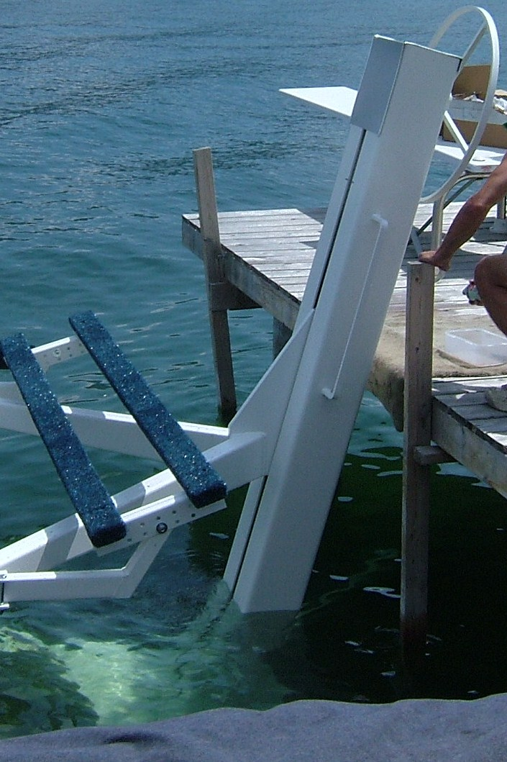
Access lower grease nipples tower slot

Black Phenolic Resin type Wheel Rollers

Four Grease nipples in equal opposite quadrants

Chain Links fall perfectly straight not twisted

Upper Limit Marks
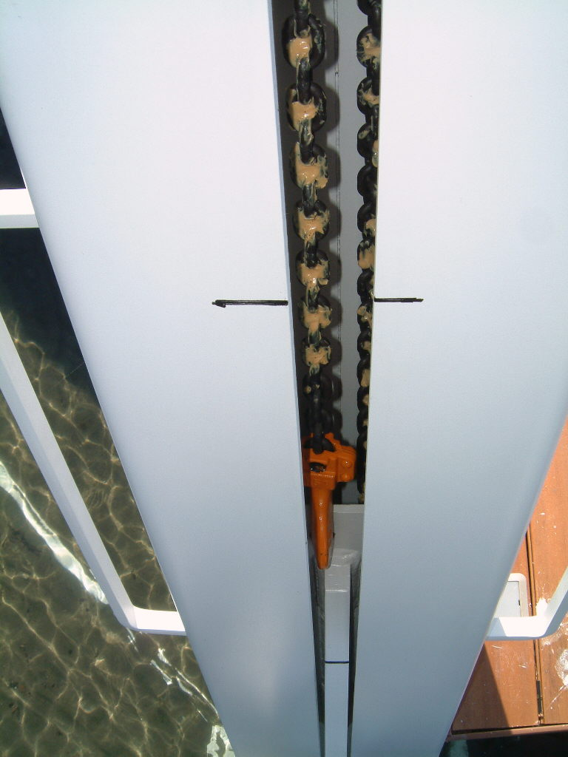
Upper grease nipples inside tower left and right at this point
Visual Aid Mark for Height and Depth

Carriage Cradle
Chain Hoist Lift Hook

